EEE3088F 2022

Team 9 Concept Proposal

# Q1 Enviro sensing HAT Concept [5]

The desired system will attach to the outer wall of a hydroponic grow tray, specifically a wick watering system. The system will monitor the water quality by measuring its temperature, acidity, and depth. The ambient humidity and light levels on the surface will also be monitored. The system is intended to allow for easy checking of the above quantities, while also storing a log of prior values (recorded at desired time intervals). Current values may be checked using an on-board LCD display. This system could be implemented modularly in large scale hydroponics grow tents and could be used to interface with automated farming practices.

# Q2 Requirements [10]

## Hydroponics hobbyists

* R1.1: Simplicity in setup
* R1.2: Simplicity in operation
* R1.3: Affordability

## Large scale hydroponic cultivators

* R2.1: Modularity
* R2.2: Optimised power consumption
* R2.3: Longevity

## Botanists and other scientists

* R3.1: Accuracy
* R3.2: Reliability
* R3.3: Thorough logging

# Q3 Project Subsystems Block Diagram [5]

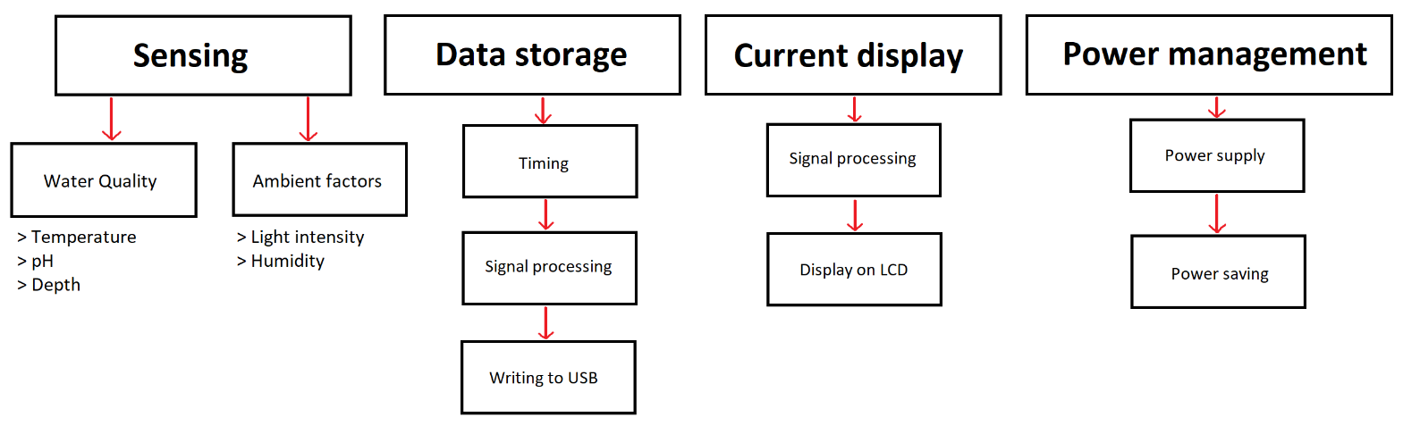

# Q4: Link to Team Git Repo [5]

Github Repository:

* https://github.com/the-user-created/EEE3088F-Team-9